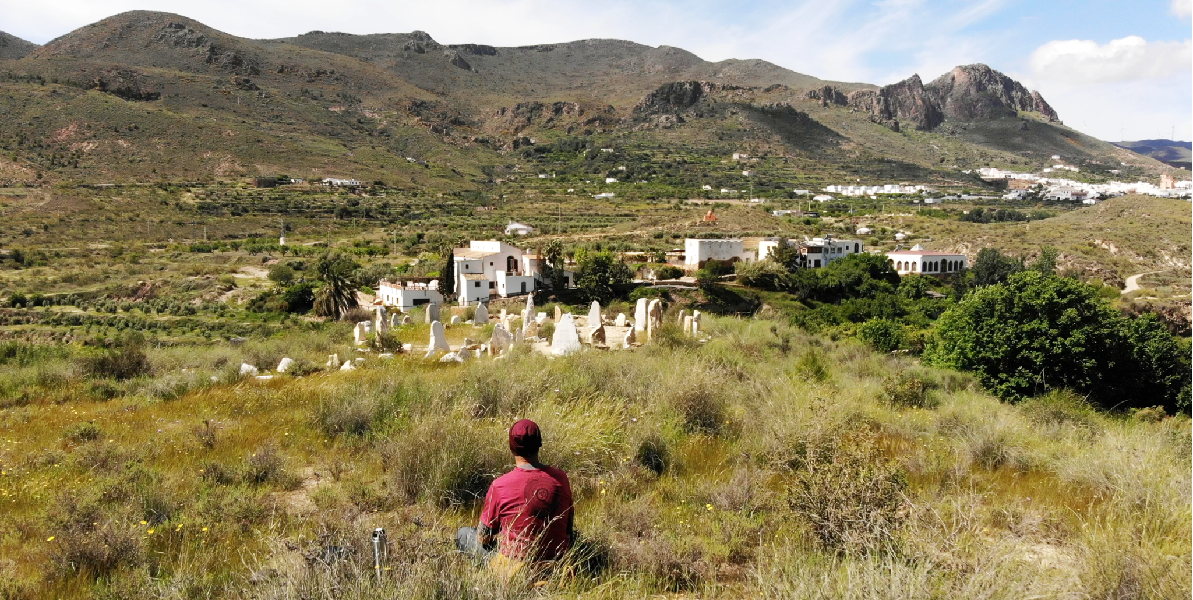
Full Permaculture Design Course Oasis Al Hamam
Learn about Permaculture and how to design sustainable and regenerative systems!
Why
More and more people are starting to realize that living in a more sustainable way is the best next move they can make going forward. Permaculture is a way to obtain practical skills to achieve this goal, as well as teaching us how to communicate in a non-violent way. Some people have found that a Permaculture Design Course represents a pivotal moment in their life, and marks a transition towards a healthier relationship both with ourselves and everyone and everything that surrounds us.
Where
Oasis Al Hamam, Almería - a wellness retreat centre located close to the Tabernas desert in Southern Spain.
When
September 26th - October 11th, 2025
Language
English
Price
Course price, including 90+ hours of theory and practical permaculture classes: €450 until July 1st (early bird discount) or €500 from July 2nd until September 15th. Accommodation including full board will be charged separately. Classes will be given by four passionate permaculturists, who will be sharing their years of experience obtained in different parts of the world. Participants also receive a certificate that they have completed a recognised PDC at the end of the course.
Important note: Places can only be reserved once a EUR 200 non-refundable deposit has been made.

Book Now!
Register your interest by filling in the inscription form here:
https://docs.google.com/forms/d/1VQaIB8Z1mmPuBDz8EGxofd54rHazarTTncTgD84NZMY/edit

Course location
Oasis Al Hamam, Lucainena de las Torres, Almería
We feel extremely honoured to have this opportunity to host a PDC at the Oasis Al Hamam, an internationally recognised wellness centre, located on the site of an ancient Roman - Arab spa.
The centre is situated just outside Lucainena de las Torres, recognized as one of the most beautiful villages in Spain, between the Cabo de Gata beaches and the Tabernas Desert, the latter famous for hosting several classic spaghetti westerns.
This charming Andalusian corner, surrounded by mountains and clear skies, stands out for its tranquility, its Moorish streets full of history and the famous Vía Verde, a hiking and cycling byway that crosses incredible landscapes.
Oasis Al Hamam: a short history

The Cortijo (Farm/Hamlet) Los Baños, where the Oasis Al Hamam is located has existed for 100s of years, and there is ample archeological evidence that it served as a spa in Roman times, and as a health and agricultural centre during the Arab colonization, Al Hamam is Arabic for Los Baños.

Between 1800 and 1930, Cortijo Los Baños lived a golden age as a spa, known and revered for the curative properties of its sulfurous waters. The history books tell us that Don Francisco Gómez, a visionary of his time, built a health complex and hamlet, restored the natural spring and spa, and created a sanctuary of wellness and rejuvenation.

One of the children of the village, Esperanza (which means hope) often worked with her father in the hills above the cortijo, collecting grasses for weaving and making shoes. From time to time she would say to him “Daddy, I would love to live in that cortijo”. And her father always replied with love and tenderness “Stop dreaming little one, for we are poor people”.

Esperanza grew up and fell in love with a lad, Pedro, from a nearby village. They married and emigrated to Cuba, where they worked hard, overcoming many obstacles. One day a miracle happened - Pedro won the lottery! With this sudden fortune they returned to their village, Lucainena de Las Torres, in Spain, together with their two children, and with Esperanza waiting for a third. One day Pedro said to Esperanza “Let's go for a short walk”. When they arrived at the gates of El Cortijo Los Baños, Pedro took some large keys out of his pocket and handed them to his wife. “Here are the keys to your new home” he said.
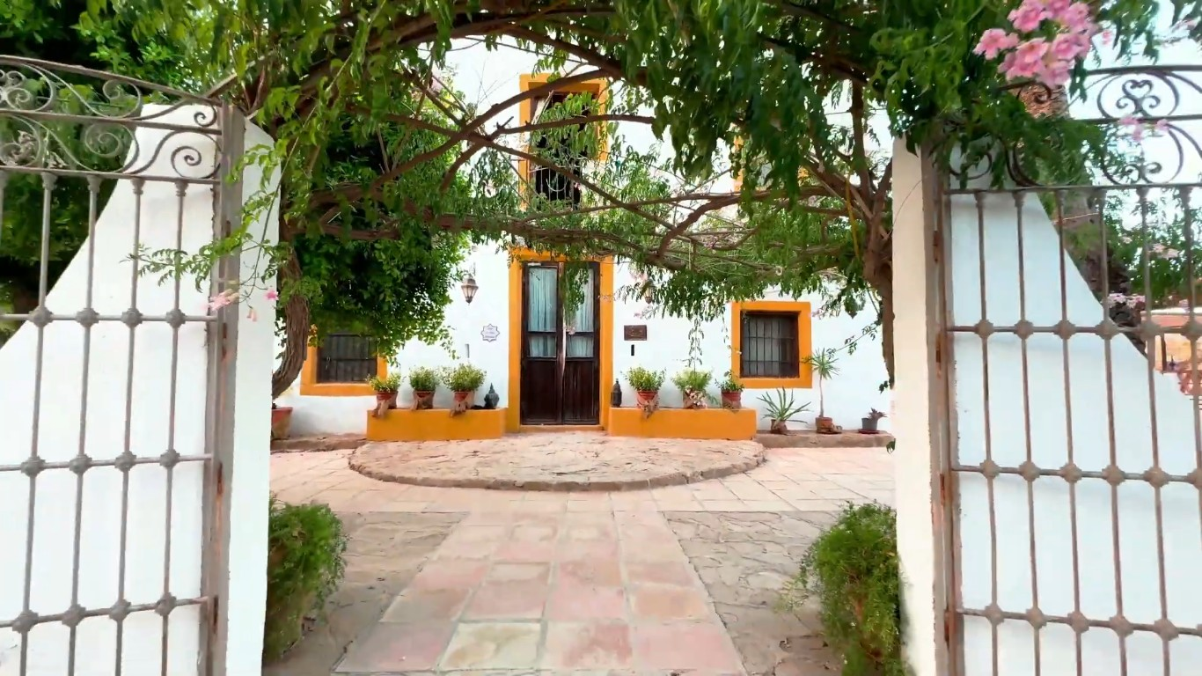

And more recently…..

Twenty five years ago, Juan Segura, Esperanzas grandson, left his veterinary studies, came back to his family home, and gave new life to the Oasis. On the summer solstice of 2001,he opened its doors as a refuge of peace, health and connection: a home for those who long for rest, nature and re-connection.
Today, Oasis Al Hamam is much more than a physical space: it is a dream that has grown with each person who has formed a part of this vision. It is a community of creative souls who contribute their talents to build together a place of transformation. Here, families, children and people with diverse concerns live together, integrating spirituality, ecology and community life.
Since its inception, respect for the land has been fundamental. The rehabilitation of the cortijo, the expansion of the organic gardens, reforestation, and animal care have created a sustainable ecosystem, where each person contributes their essence to continue growing and co-creating together.
Oasis Al Hamam is also a school of life, offering courses and retreats focused on personal development, art, health and permaculture. It also welcomes children and young people to learn about rural traditions and sustainable living.
We also welcome those seeking awareness and connection with nature. Here, spiritual practice transcends each religion, to focus on the common essence: manifesting “love in action” in the present .
This is a sacred space where you learn to feel Mother Earth in every step, to celebrate life at its best and to discover your own purpose.
It is a place where dreams blossom and their seeds transform the world.
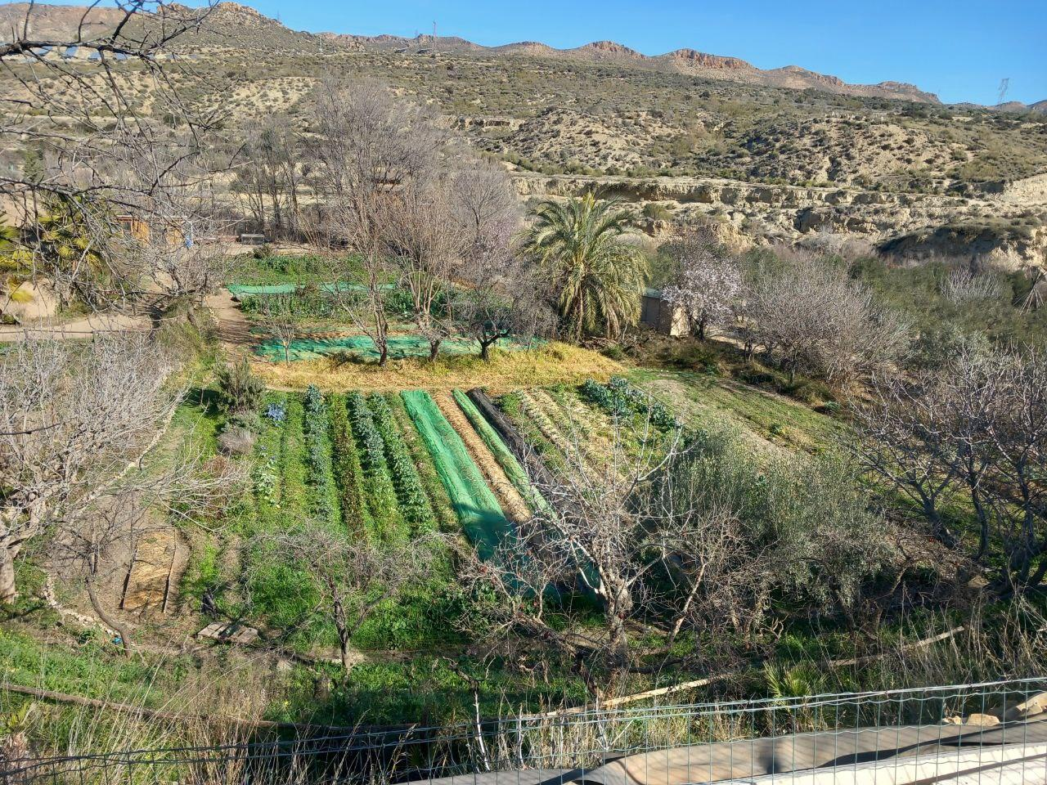

Course Description
Permaculture aims to create systems that create harmonious connections between humans and the planet. The Australians Bill Mollison and David Holmgren coined the term in the 70’s, a combination of the words “permanent” and “agriculture. Permaculture ethics, principles, and design techniques were first used to develop sustainable agricultural systems as an alternative to the growth of agro-industry and the consumer economy. From these beginnings, the concept of Permaculture has expanded and diversified to cover nearly all types of human-based systems.
Permaculture design courses (PDCs) have been developed as an introduction to this way of thinking and teach the tools and techniques needed for participants to design their sustainable systems. These courses are taught through both theory and practice and weave in both ancestral knowledge and recent discoveries. At Sunseed we showcase many examples of Permaculture in practice.
In this two-week PDC, we use the basic curriculum as set out by the UK Permaculture Association and supported by the Southeastern Spanish Permaculture Network (REPESEI).
The course will take place in a real context, in which the participants have the opportunity to gain first-hand knowledge of how, at Oasis Al Hamam, we work to create a biodiverse and balanced environment, where sustainable rural cultural practices are honoured. Here we aim to imitate natural ecosystems in order to provide a space where people, plants and animals can live in harmony. This system is healthy, sustainable and auto-regulating, thus ensuring its continuity, and prosperity.
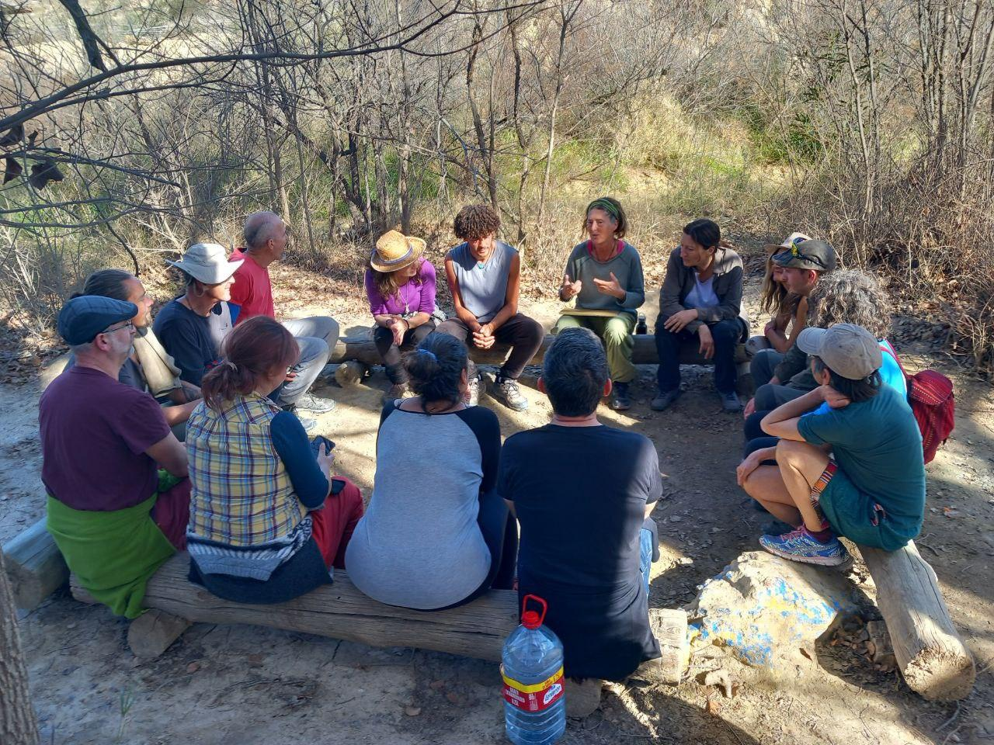

Course content
We will follow the course curriculum as set out by the UK Permaculture Association and supported by the Southeastern Spanish Permaculture Network (REPESEI).
In addition to the theory, we will do many practicals in order to learn by doing, as well as a group final design. This will be done by participants using a Permaculture design framework, as well as all the theoretical knowledge gained during the course, and the knowledge and experience each person brings.
Main subjects covered:
1. A short history of Permaculture, ethics and principles (Mollison y Holmgren)
2. The design process itself: survey - analysis - design - implementation - maintenance - evaluation - tweaking.
3. Designing for climate emergency: food independence, communities
4. Soil structure and the soil ecosystem: fertility, sampling and analysis, management, regeneration (especially in arid environments).
5. Water: the water cycle, water availability, capture and storage, retention in the landscape.
6. Plants/trees: basic botany, the ecology of a forest, forest management, types of forests.
7. Sustainable farming systems, including regenerative agriculture, natural farming, and syntropic agriculture
8. Wellbeing and self-care: symbiotic nutrition, integrative medicine
9. Natural building
10. Appropriate technology
11. Social Permaculture: community living, participatory decision making, transition economics.
Practicals
- Community building and non-violent communication.
- Reading the landscape + observation techniques.
- Forest bathing
- Basic mapping: aspect, scale, how to mark out contour lines, trilateralization
- Contour line measuring
- Water retention systems
- Soil analysis
- Soil regeneration techniques
- Regenerative and syntropic agriculture systems
- Natural building
- Sociocracy
- Design time

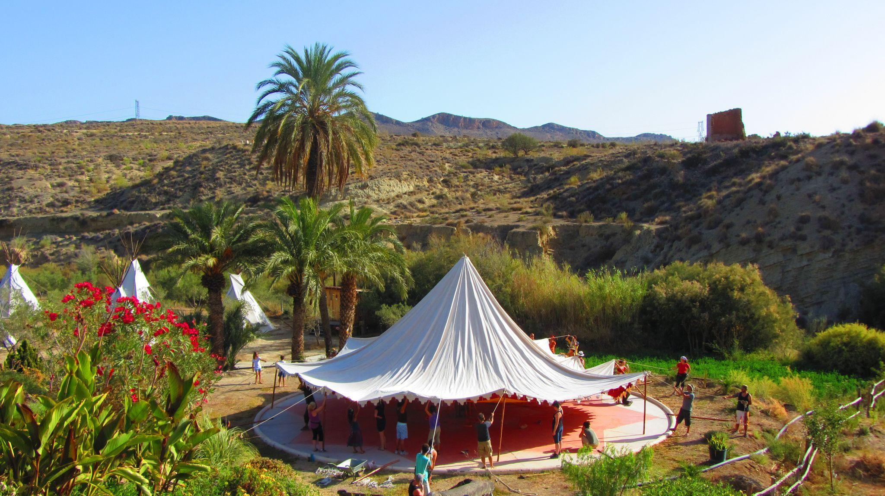

Who we are
Frances Osborn (teacher)
Frances is an ecologist with a degree in Environmental Sciences from Southampton University, UK, and a PhD in Insect Ecology from the Simón Bolívar University, Venezuela. In 2014, after 10 years working as a research scientist at the Eastern University, Venezuela, she returned to Europe where she did her first PDC in Brighton, UK. She has been studying and practicing permaculture ever since, and graduated with a Diploma in Applied Permaculture in March 2021. She has been teaching PDCs since 2019 at different venues, including Proyecto Rucula in Murcia and the Suryalila Yoga Retreat in Cadiz.
Frances has extensive experience in garden and agricultural systems, gained from her many volunteering placements, including two years at the first Ecosystem Restoration Camp in the dry highlands to the northeast of the Murcia region in southern Spain. She is currently helping to restore an old stone cottage near Calasparra, Murcia using natural building techniques.
Frances is currently secretary for Urban Street Forest, an association based in Holland and Spain that seeks to reforest degraded drylands, and is also secretary for the Permaculture Network in south-eastern Spain. Frances has made volunteering her main lifestyle choice, a path which has led her to minimize her costs rather than maximize her income, and gives her the freedom to take up opportunities as they appear. Travel plays an important role in her life and the bicycle is her preferred mode of transport, as this enables her to slow down, appreciate the scenery, and enjoy the journey.

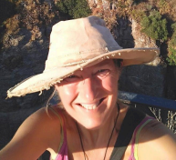

Luis Simada (teacher)
Luis is a permaculture advisor, designer and teacher and also networks facilitator. He is trained as a designer, group facilitator, permaculture teacher, fermenter and project coordinator. He participates and actively contributes in different social, activist and alternative movements like iberian southeast permaculture network (REPESEI), La Espiral del Sureste Ibérico , the Iberia Ecovillage Network (RIE), Cauac Editorial Nativa or Social Permaculture Movements... and he is coordinating the Ecosystem Restoration Department in Sunseed. He have also been teaching different courses about Symbiotic Nutrition, Regenerative and Natural Agriculture or Appropriate Technologies. He really appreciates discovering new ways to create resilience and communities, that's why he is also Simada, traveling around Iberia supporting and designing alternative projects while keep going learning in each one of them. He loves listening, expressing his emotions, creating new ferments and healthy recipes, doing experiments, designing social solutions, playing, wild nature, ancient trees, ancestral traditions and live music.

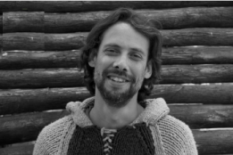

Juanma Pinar (teacher)
Juanma is an Andalusian biologist mostly focused on botany and agro-ecology (University of Seville, SP) with masters on winemaking & viti-vinicole environment (University of Bordeaux, FR). After a few years of working/traveling around the world in diverse kinds of vineyards -making different styles of wines- he started to worry about the big impact this huge industry has on the environment (waste of water, death of soils, harmful pesticides, elitist markets,...) so he came back home and deeply started to melt into permaculture philosophy. He obtained his PDC in early 2020 in “Centro Extremeño de Permacultura La Caraba” (Cáceres), and a following “introduction to bioconstruction” course in Alcañiz (Erasmus+, Teruel), plus a certificate of “nature activities instructor -educational and social potential-” from Andalucía GDR (Development Rural Group). Then he started to collaborate into a community garden integrated in a natural park in his town (Ecohuerto Los Toruños, Cadiz) and joined climate justice movements such as Extinction Rebellion and “Ecologistas en Acción”. In parallel he was working as environmental educator for different local enterprises (Ecoherencia, Caucenatura) mostly centered on agro-ecology, nature hiking and other active learning services for public schools.
At the moment he is leading the gardens’ team in Sunseed that is: fixing and redesigning the irrigation systems, restoring poor soils with -animal/green manure, compost and mulching refreshing the old seedbank, replacing losts with new plants adapted to drought, researching on edible and medicinal wild-plants-based preparations, improving associations/rotations of crops, and a long etcetera of learn-by-doing processes.
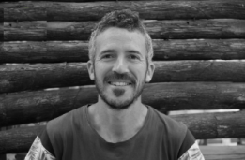

Marco (teacher)
My journey began in Rome, where I was born 33 years ago with a deep love for nature. Growing up, I pursued my passion by studying Forestry Sciences and Nature Conservation, which took me on exchanges to Slovenia, Portugal, and Germany, broadening my understanding of sustainable resource management.
Completing my studies with a doctoral program in wood technologies and composite materials at the University of Hamburg, I discovered the potential of recycled materials for social housing, leading to collaborations with Ethiopia and South Africa.
Feeling a stronger connection to nature, I moved to Spain, settling in Los Molinos de Rio Aguas, an off-grid village. Here, I immersed myself in local projects and started cultivating food in our garden, finding fulfillment in sustainable living.
Now, I'm thrilled to share my journey and passion for permaculture in this course, eager to learn and collaborate for a more sustainable future.
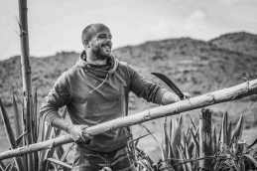

Neil - Host and Coordinator

From traditional farming family roots in the Cotswolds to Oasis Al Hamam in the Andalusian desert, Neil’s journey has gone from farming to business and modern languages studies to international account management of medical devices and back down to earth; assisted by over twenty years practicing yoga and teaching for the last ten.

After stepping away from international business Neil discovered permaculture at a retreat centre in southern Portugal and went from there to Ibiza where he completed a permaculture design course at Casita Verde with Circle Permaculture and worked developing a project on the island.

His curiosity and new nomadic lifestyle took him to visit and participate in numerous projects and communities in Spain and Portugal and to join the permaculture network events in southeastern Spain. An Iberian Ecovillage Network (RIE) event at Oasis Al Hamam enticed him to the project where he has lived for the last three and a half years.

Neil forms part of the coordination team with particular focus on gardens, eco construction projects and events organised by Oasis Al Hamam. He also shares his yoga practice with the community and will be the main point of contact for the group during the PDC.

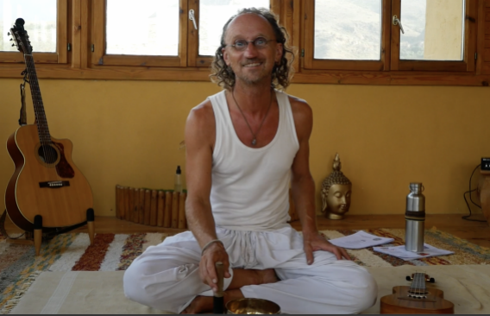

Our certifying Association
REPESEI, the Southeastern Spanish Permaculture Network.
Towards the end of the 1980s the seeds of the REPESEI (Red de Permacultura del Sureste Ibérico) were sown by a small group of locals and travelers.
This small group organized gatherings, workshops and courses, during which ideas of alternative ways of understanding life began to germinate and grow, answering the questions and needs of the individuals and groups that attended them.
In 1996, Rosa Mejuto along with a women’s group, and inspired by Permaculture Movements and Natural Agriculture, founded the REPESEI. The number of gatherings and Permaculture Projects increased, from which a network started to spread – and is still growing.
Since then there have been a large diversity of workshops and courses given and promoted by the network, among which we can highlight those by Jairo Restrepo (Columbia) and Nacho Simón (Mexico), that have taught us new ways to care for life in the soil under our feet, improving its fertility, and harmonizing the relationships between it and the plants we cultivate. Many of us now make our own bio-preparations.
Furthermore, there have been many Permaculture gatherings held at many sites from Alicante to Málaga. Currently there are 4 gatherings yearly in Winter, Spring, Summer and Autumn, as well as a mutual support network (TAM - Tragozando Apoyo Mutuo) that support projects throughout south-eastern Spain.
Dates
September 26th to October 11th, 2024.
You should arrive on Friday, September 26th in the afternoon / evening. Classes will start on Saturday, September 27th in the morning.
The course will end with the design presentations on Saturday, October 11th and an evening celebration. Participants should leave on Sunday, October 12th before 13:00 hrs. There will be two free days mid-course. Classes will start daily at 8:00 am and end at 8:00 pm before supper. We always start the day with a morning circle to check in with each other, and inform about the day’s programme and any logistics
Pricing
The cost for the PDC will be EUR 450 until July 1st (early bird discount) and 500 from July 2nd until the September 15th + accommodation + food costs and includes:
❖ Teaching (theory and practice) by a diverse group of passionate permaculturists all of whom bring their own knowledge and experience in the different permaculture fields (or Permaculture Petals).
❖ An officially recognised certificate at the end of the course.
❖ At Oasis Al Hamam there is lots of space to be on your own or to walk through the beautiful valley.
❖ Telephone coverage and Wifi
Accommodation + Food (separate cost)
Accommodation prices, including full board, are given for the whole course (16 nights) and range from your own tent or camper van for EUR 650 p/p to EUR 960 p/p for a bed in a double room with a private bathroom.
Beds will be allocated on a first come, first served basis.
Please contact Juanma (contact details below) for further details.
Food and Beverages
All food and (non alcoholic) drinks will be provided during the whole course. We serve vegan/vegetarian food at Oasis Al Hamam, but please talk to us about special wishes for food or allergies.
Coffee, herbal teas, and drinking water will be available throughout the course. You can also bring private snacks and treats for your well-being with you.

Booking and cancellations
Register your interest by filling in the inscription form here: https://docs.google.com/forms/d/1VQaIB8Z1mmPuBDz8EGxofd54rHazarTTncTgD84NZMY/edit
Important note: Places can only be reserved once a EUR 200 non-refundable deposit has been made.
What if my plans change: A full refund minus the deposit can be made up to one month (August 26th) before the start of the course. This will be reduced to a 50% refund (minus the deposit) two weeks (September 12th) before the start of the course, and a 25% refund (minus the deposit) two days (September 24th) before the start of the course. This applies to the cost of the course only.
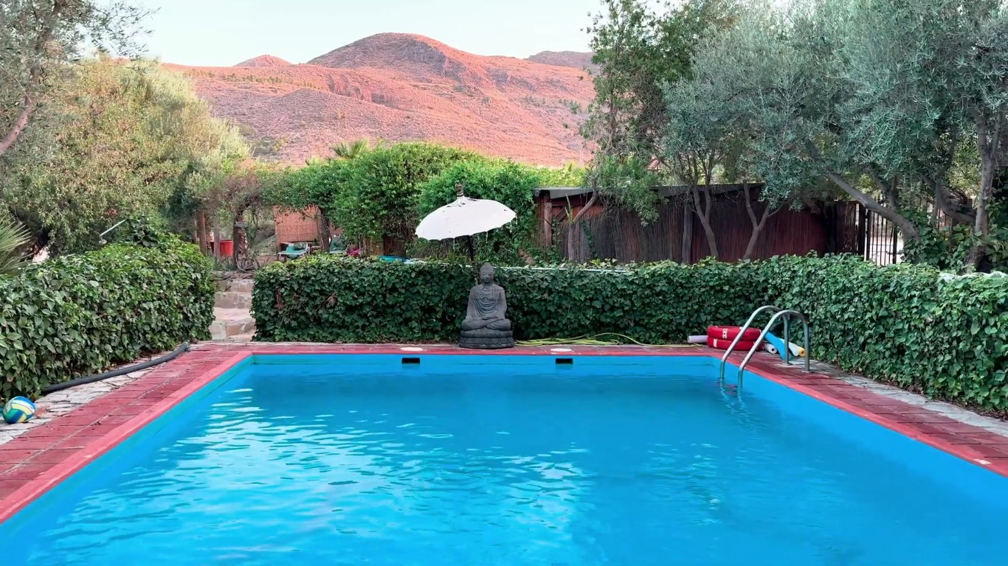
How to get here
El Oasis Al Hamam lies just outside Lucainena de las Torres, a small village in Almeria province located 45 minutes by car from Almería city.
Since Lucainena is a small town, we will organize a pick-up from Sorbas (nearest town with bus connections) to Al Hamam. If your idea is to fly to Spain, the nearest airport is Almería Airport (LEI). You can usually fly cheaper, though, if you go to Málaga Airport (AGP) or Alicante (ALC).
- From Málaga Airport to Almería, take a bus to Almería. The journey takes approximately 3 hours and 30 minutes and costs 22 EURO (one way).: Check bus timetables AGP-Almería here!.
- From Almería Estación Autobús. There are several buses per day to Sorbas.
The schedule varies depending on the day:
- Mondays to Fridays: 8:30, 11:00, and 15:30.
- Saturdays: 11:00.
- Sundays: 8:30 and 11:00.
- From Alicante to Almería you can take a bus to Murcia which has daily direct connections, and from there take a transfer to Vera. Then from Vera, there is the connection to Sorbas by bus. Check here the bus timetables Vera-Sorbas.
Make sure to check the bus timetables and availability in advance, especially for connections from Málaga and Alicante.
Please note that activities will start on Saturday, the 26th of September at 8:00 am, so please organize yourself in order to be able to arrive on Friday evening.
Activities will end on the evening of Saturday, the 11th of October, so you can plan your trip back to your country starting from Sunday, the 12th of October, in the morning.
Book now: Register your interest by filling in the inscription form here: https://docs.google.com/forms/d/1VQaIB8Z1mmPuBDz8EGxofd54rHazarTTncTgD84NZMY/edit
Important note: Places can only be reserved once a EUR 200 non-refundable deposit has been made.
Contact details
cursos@permaculturasureste.org
Juanma Pinar: +34 605 125 477

